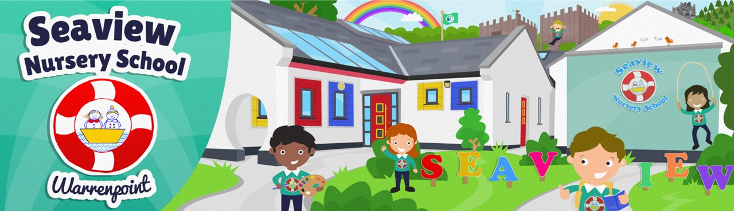

**Applying for a place at Seaview Nursery School**

**You are advised that EA Connect is currently open for** **online applications,**   
**closing** **at 12 noon**, **Friday 24 January 2025**

To apply, visit: <https://www.eani.org.uk/parents/admissions/pre-school-admissions-guide>

If additional information is required or any difficulty is experienced, parents can contact the admissions helpdesk via the email address: [preschooladmissions@eani.org.uk](mailto:preschooladmissions@eani.org.uk)   
or by calling **028 9047 0177** Monday - Friday 9am - 5pm